

**Introduces**

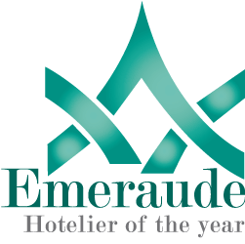

**EMERAUDE HOTELIER**

**Certification for Sustainability in Hospitality**

# **Team for the Emeraude Hotelier Certification**

These certification guidelines were compiled by the International Hotel & Restaurant Association Technical and researcher Team.

**Authors and Researchers**

Dr. Ghassan AIDI, *President*

Ms. Christine Kaufmann, Head researcher

Mr. Jack Nader (USA), Tatiana Burlap (ASIA), Nathalie Valier (EUROPE), James Groves III (USA), Katarina Melodic (Balkans), Astrid Gomez (South America) .,

**Editor and Designer**

Ms. Leila Sidawy

Copyright © 2010

International Hotel & Restaurant Association (IH&RA)

42 Avenue General Guisan (Lausanne)

CH-1209 Pully, Switzerland

Phone: +41 21-711 4283| fax: +41 21-711 4284

Email: [info@ih-ra.com](mailto:info@ih-ra.com), **ihra@live.com** | [www.ih-ra.com](http://www.ih-ra.com)

**Content**

**Team for the Emeraude Hotelier Certification** i

**1**  **Introduction** 1

**2**  **The Advent of Global Partnerships for Sustainable Tourism** 3

**3**  **The Emeraude Hotelier Certification: An Overview** 4

3.1 Mission Statement, Goals, and Requirements for the Emeraude Hotelier 5

3.2 How to Become an Emeraude Hotelier 6

3.3 Evaluation 10

**4** **The Criteria of the Emeraude Hotelier Certification** 13

**A**  **Demonstrate Effective Sustainable Management** 15

A1 Sustainability Management 17

A2 National Legislation and Regulation 20

A3 Staff Training 21

A4 Customer Satisfaction 22

A5 Promotional Materials 23

A6 Design and Construction of Buildings and Infrastructure 24

A6.1 Local Zoning and Protected/Heritage Areas 24

A6.2 Natural/Cultural Heritage 25

A6.3 Sustainable Construction 26

A6.4 Persons with Disabilities 27

A7 Information about and Interpretation of Cultural/Natural Heritage 29

**B** **Maximize Social & Economic Benefits to the Local Community, Minimizing Negative Impacts** 30

B1 Social and Infrastructural Community Development 31

B2 Employment of Local Residents, Women and Minorities 32

B3 Exploitation of Children, Women and Minorities 33

**C** **Minimize Negative Impacts to Cultural Heritage and Maximize Benefits** 34

C1 Historical and Archeological Artifacts 35

C2 Protection of Local Historical, Archeological, and Cultural Properties 36

C3 Local Art, Architecture, or Cultural Heritage 37

**D** **Minimize Environmental Negative Impacts and Maximize Benefits** 38

D1 Conserving Resources 41

D1.1 Environmentally-Friendly Products 42

D1.2 Measuring of Disposable and Consumable Goods 44

D1.3 Measuring Energy 45

D1.4 Water Consumption 46

D2 Reducing Pollution 51

D2.1 Greenhouse Gas Emissions 52

D2.2 Wastewater 60

D2.3 Waste Management Plan 61

D2.5 Pollution from Noise and Light 63

D3 Conserving Biodiversity, Ecosystems and Landscapes 64

D3.1 Protected and Threatened Species 65

D3.2 Captive Wildlife 66

D3.3 Adverse Effects 67

**5** **Document Examples** 68

5.1 Emeraude Team 69

5.2 Sustainability Policy 71

5.3 Action Plan 73

5.4 Emeraude Team Meeting Plan 74

5.5 Staff Training Plan 75

5.6 Consumption Spreadsheet 76

5.7 Inspection Spreadsheet 77

5.8 Water Quality 78

**Appendix** 79

# **1 Introduction**

During the last few years, the sustainability debate has become increasingly popular as a response to the rapid development of globalization during the 20th and 21th century. The globalization process has unquestionably stimulated technological progress, productivity, growth, and enhanced living standards; however, it has also intensified social and economic imbalances in certain parts of the world, as well as harmed the earth’s ecosystem.

Due to disparate levels of development, not all countries are affected by the globalization in the same way, and thus, not every country is able to benefit from the globalization process. Moreover, the capacity of developing countries – such as small island-states and African states – to adapt to the climate change is weak. Due to lack of resources and funding, these populations are more affected by the climate change because they are unable to adapt.

In 2002, responding to these circumstances, the United Nations Secretary-General developed a global Action Plan containing the eight Millennium Development Goals in order to reverse poverty, hunger and disease. The deadline for accomplishing these goals is by 2015.

Tourism is a fast-growing sector, and is a major factor in accelerating the globalization process. However, tourism is also an opportunity for job creation in all countries – both industrialized and developing – enhancing the local economies and raising the standard of living. To secure such long-term developments, the tourism-and-travel sector should adhere to sustainable tourism on the basis of the Millennium Development Goals.

Sustainable tourism can be achieved when developing processes are designed on a long-term basis, encouraging environmental and social responsibility, as well as higher economic productivity.

The International Hotel & Restaurant Association (IH&RA) believes that its members can subscribe to sustainable development by implementing hospitality management that responds to both the climate change by reducing carbon emissions, and also to socioeconomic imbalances by respecting the culture of each community.

Environmental awareness has risen in the last few decades. Hotels and tourism destinations that do not respect sustainable principles run the risk of incurring a loss in clientele. Meanwhile socially-responsible and environmentally-friendly managements will see an increase in business. Moreover, the hotels that implement sustainable principles will be better positioned for the inevitably more stringent environmental regulations.

Even during times of economic uncertainties, sustainability is an opportunity to stimulate economic development in the tourism sector.

IH&RA promotes hospitality as a key industry in combating climate change, as well as poverty, hunger and disease. Encouraging investment in green infrastructure, IH&RA enforces the development of sustainable tourism.

# **2 The Advent of Global Partnerships for Sustainable Tourism**

In 2008, the United Nations Foundation in Washington, DC invited IH&RA, as well as twenty-five other organizations at the time, to define a global standard for sustainable tourism out of the hundreds of existing practices worldwide.

The Global Partnership for Sustainable Tourism Criteria was established with the coalition of these twenty-six organizations, working together to foster an increased understanding and implementation of sustainable tourism practices.

IH&RA adopted the criteria with slight modifications to be more oriented toward the hospitality sector. The hospitality criteria, as defined by the Emeraude Hotelier certification, should be considered a baseline which a hotel owner or manager should try to implement.

The criteria are part of the tourism industry’s response to the global challenges of the Millennium Development Goals, such as climate change and poverty reduction.

# **3 The Emeraude Hotelier Certification: An Overview**

In regard to the growing ecological threats and the increasing sensitivity of the environment, many eco-labels were developed to increase Green Hotel Management. The Emeraude Hotelier Certification wants to take a step forward by implementing all-inclusive guidelines that consider the correlation between the hotel industry and the natural, social, cultural and economic environment.

Eighty percent of all hotels are small- and medium-enterprises (SMEs), at different stages of organizational development – only 20% consist of large enterprises, such as hotel chains. That being said, there are only few international standards for the hospitality industry, and national regulations differ greatly from one nation to the next. Therefore universally-recognized standards have to be defined, and these standards must meet the different needs of hotels worldwide.

Such is the need for the Emeraude Hotelier Certification. Hotels will be awarded with the Emeraude Hotelier recognition if they successfully implement the guidelines stipulated to enhance sustainable tourism. The certification should serve to motivate hotel managements as well as their staff to continuously develop sustainable practices. Moreover, the hotels’ business partners may be positively influenced to restructure their practices. Lastly, the hotels guests will perceive these sustainable actions, and thus be inspired to uphold responsible tourism.

## 3.1 **Mission Statement, Goals, and Requirements for the Emeraude Hotelier**

**Mission Statement**

* To encourage ethical business practices
* To guarantee that all hotels, partners and guests implement sustainable practices

**The Goals**

* Diminishing environmental risks at minimal cost
* Raising environmentally- and socially-responsible standards
* Encouraging hotels to define the aims that best suit them

**Requirements for Hotel Management**

* Creating and applying a sustainable policy and Action Plan
* Commitment to sustainability, during and after the certification

## 3.2 How to Become an Emeraude Hotelier

**Procedure**

1. An IH&RA ambassador visits the hotel to explain the Emeraude Certification procedure.
2. Signed application form and payment are sent to IH&RA in order to receive the Emeraude Hotelier Certification handbook.
3. Once all procedures are completed, the Documentation Handbook is sent to the auditing agency of IH&RA.
4. An IH&RA ambassador visits the hotel to evaluate the actions on site.
5. If auditing is successful, the hotel receives:
   1. An Emeraude Hotelier plaque with the year of the certification, and the number of Emeraudes that were achieved
   2. An Emeraude Hotelier certificate
6. The hotel will be recognized at the next Annual IH&RA Congress.
7. Regular updates and information will be sent to all Emeraude certificated hotels.
8. After two years the auditing must be renewed in order to be certified for another two years.

**Documentation Handbook**

In order to become an Emeraude Hotelier, the Emeraude Team (see below) is asked to create a Documentation Handbook that will be sent to the auditing agency of the IH&RA once all assignments are completed.

The handbook consists of following elements:

IH&RA can be asked for assistance to create the Documentation Handbook.

**Emeraude Team**

The Emeraude Team consists of members dedicated to achieving the Emeraude Hotelier certification. The team must be assigned a coach who will be responsible for the whole certification procedure. The coach then needs to choose key employees who assist him and take over different assignments. (See section 5.1 for an example)

**Sustainability Policy**

The Sustainability Policy will be the core element of the Emeraude Hotelier certification. It defines the sustainability profile and the goals that the hotel pursues for the next two years. (See section 5.2 for an example)

**Action Plan**

The Emeraude Team details measures for sustainability and compose an Action Plan. These measures must adhere to the Emeraude Hotelier criteria of sustainability. A checklist helps to identify the necessary actions (see Appendix).

The Action Plan will be the basic instrument of the certification. It determines not only the measures, but also the current state, the desired state, timeframe, execution, assessment, and if necessary budget. (See section 5.3 for an example)

**Other documents**

Some criteria require specific documents, for instance meeting plans for staff training, spreadsheets, etc. (See section 5.4 to 5.6 for examples)

**Certification Renewal**

**Certification Costs**

|  |  |  |
| --- | --- | --- |
| Members | Independent members of IH&RA | €1,500* |
| Indirect members  (via National Associations and Chains) | €2,000* |
| Non-Members | Non IH&RA Members  (includes membership into IH&RA) | €5,000* |

*Costs include two-year certification. Travel fees for IH&RA ambassador visiting the hotel and his expenses during the inspection do not apply. Payment is non-refundable. Certification renewal after two years is €500, excluding travel fees and expenses during the inspection.

## 3.3 Evaluation

The Emeraude Hotelier certification is based on a three-level scale. According to the number of criteria the hotel fulfills, it will be awarded with one, two or three Emeraudes:

  

The evaluation concept of the Emeraude Hotelier certification should enable all hotels to participate regardless of their size and their level of organizational development.

Some criteria of the certification may not apply to some hotels while others are very useful. For this reason, each level stipulates mandatory criteria and a number of optional criteria.

**Levels of Achievement for the Emeraude Hotelier**

In order to obtain one, two or three Emeraudes, the hotel has to fulfill a certain number of criteria:

|  |  |  |
| --- | --- | --- |
| No. of Emeraudes | % of Criteria | Description |
| http://www.ih-ra.com/programmes/images/emeraude.gif | **At least 50%** | The hotel applies basic principles that help to protect the environment and makes efforts towards sustainable tourism. |
| http://www.ih-ra.com/programmes/images/emeraude.gifhttp://www.ih-ra.com/programmes/images/emeraude.gif | **At least 60%** | In addtion to the first level, the hotel improves its environmental activities through investments in new technologies, helping to minimize negative impacts on the environment. |
| http://www.ih-ra.com/programmes/images/emeraude.gifhttp://www.ih-ra.com/programmes/images/emeraude.gifhttp://www.ih-ra.com/programmes/images/emeraude.gif | **At least 75%** | In addtion to the second level, the hotel is on a very high level of environmental commitment by implementing energy efficient technologies. |

**Further Requirements**

There is a total number of 100 criteria, some of which are mandatory and some optional:



In order to attain **One Emeraude** the hotel must fulfill at least **50 criteria** (50%). The criteria labeled with one Emeraude are **mandatory** (40 total). The remaining 10 criteria can be chosen freely by the hotel.

 

In order to attain **Two Emeraudes** the hotel must fulfill at least **60 criteria** (60%). The criteria labeled with one or two Emeraudes are **mandatory** (50 total). The remaining 10 criteria can be chosen freely by the hotel.

  

In order to attain **Three Emeraudes** the hotel must fulfill at least **75 criteria** (75%). The criteria labeled with one or two Emeraudes are **mandatory**, as well as all of the criteria from sections A, B and C (59 total). The remaining 16 criteria can be chosen freely by the hotel.

# **4 The Criteria of the Emeraude Hotelier Certification**

This section describes all of the criteria. Go through it carefully to determine the two following goals: the hotel’s sustainability profile and how many Emeraudes it aims to achieve. Some of the criteria you may have already been fulfilled, while others may require further time and investment.

**Key Performance Areas**

|  |
| --- |
| **A Sustainable Management** |
| **B Social & Economic Benefits** |
| **C Cultural Heritage** |
| **D Environment** |

**Criteria Format**

Each of the main criteria is associated with a colored box (i). Below the box, the number of Emeraudes assigned to the criteria is indicated (ii). Then a description of the criteria follows (iii). See below.

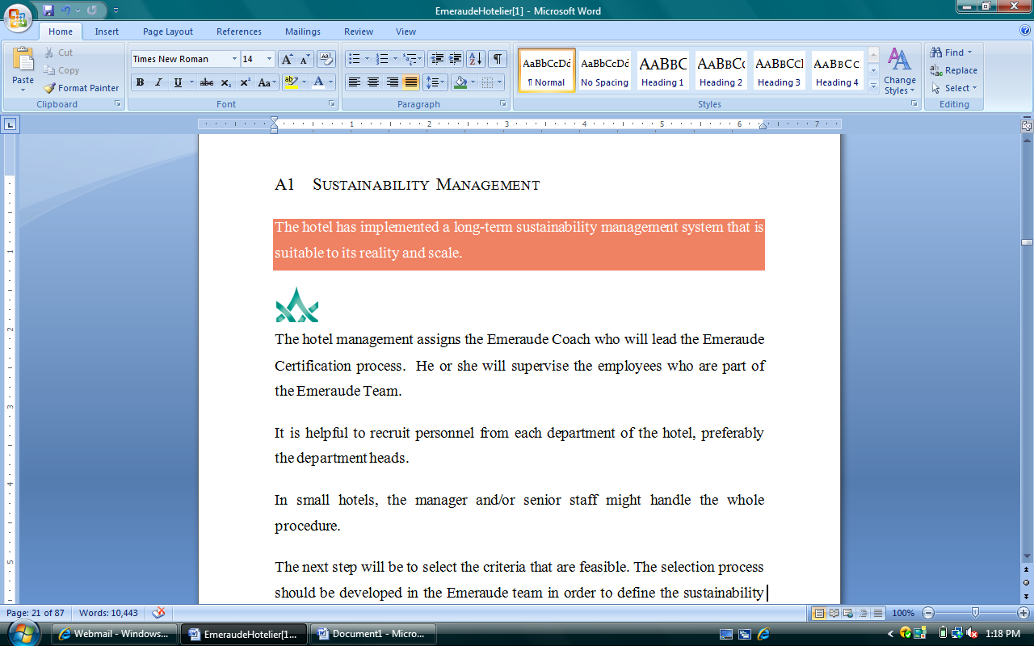

**iii**

**ii**

**i**

Within some sets of criteria exist sub-criteria. These allow the hotel the opportunity to receive multiple Emeraudes with the completion of each sub-criteria.

Now it is your turn to develop a strategy that will turn your hotel into an Emeraude Hotelier!

## **A Demonstrate Effective Sustainable Management**

An effective management is central to pursue a long-term based sustainable development of your hotel. A sustainable management involves all sustainability related activities of all departments, staff members, distributors and customers, and considers all correlations between the hotel and the external environment such as the national and local authority, the community, and the cultural and natural heritage surroundings.

Management that practices sustainability takes the responsibility and initiative for a methodical improvement of its hotel’s sustainable development.

Even though the Emeraude Coach and the team implement the certification, sustainability cannot be delegated. The hotel management has to introduce the concept to all staff members and set a good example. This includes providing the necessary resources. The inner conviction of the hotel management for sustainability is critical!

Regarding the involvement of the hotel’s staff, their motivation and qualifications determine the hotel’s success in implementing the new standards. Teamwork and comprehensive participation are preconditions for a sustainable development of your hotel. Every staff member is responsible for producing a certain service, and thus, is responsible for sustainable action. Individual initiative is important; nevertheless instruction and exchange of information will be crucial.

A systematic advancement of sustainable management will decide whether the impact of the certification will be long-lasting or not. The Action Plan will help to secure sustainability for the hotel.

**Total Quality Management**

### A1 Sustainability Management

The hotel has implemented a long-term sustainability management system that is suitable to its reality and scale.

|  |
| --- |
| http://www.ih-ra.com/programmes/images/emeraude.gif |

The hotel management assigns the Emeraude Coach who will lead the Emeraude Certification process. He or she will supervise the employees who are part of the Emeraude Team.

It is helpful to recruit personnel from each department of the hotel, preferably the department heads. In small hotels, the manager and/or senior staff might handle the whole procedure.

The next step will be selecting the feasible criteria. The selection process should be developed by the Emeraude Team in order to define the sustainability goals for the two next years. The selection of the criteria is developed carefully to establish realistic goals. The Emeraude Coach always confers with the hotel management.

Once the criteria are selected the Emeraude Team creates the Sustainability Policy. It should represent the hotel’s sustainability profile, declaring the hotel’s commitment and goals to improve sustainable action.

The Sustainability Policy has to be promoted to guests and staff members. It should be clearly displayed in several places, for instance at the front desk, in the guestrooms, etc.

After accomplishing all assignments according to the selected criteria, the Emeraude Coach prepares the Documentation Handbook that includes the Sustainability Policy, the Action Plan and all other required documents.

The Documentation Handbook needs to be accessible to the Emeraude Team as well as to the hotel management.

* **Documentation Handbook requirement**
* Hotel’s Emeraude Team List (see sample p 69)
* Sustainability Policy (see sample p 72)

All documents are arranged in a ring binder which is accessible anytime for the hotel management and the Emeraude Team.

Finally, the hotel management and the Emeraude Coach decide the desired inspection date of the IH&RA.

For the evaluation, your Documentation Handbook has to be sent to the auditing agency of the IH&RA.

Once the certification has been granted, the Documentation Handbook will be updated regularly whenever the Emeraude Team assess the results.

C:\Users\Invité\AppData\Local\Microsoft\Windows\Temporary Internet Files\Content.IE5\7T10CO3U\MCj03496480000[1].wmfThe Emeraude Coach will be a key figure in the sustainable management of the hotel. The Coach should:

* be interested in the subject of sustainability, especially in environmental issues.
* get full support of the hotel management.
* set a good example for the staff.
* delegate duties and manage the team.
* have high ability to motivate and to convince people.
* have cultural and social empathy.

**Organizational Chart**

### A2 National Legislation and Regulation

The hotel is in compliance with all relevant national legislation and regulations (including, among others, health, safety, labor and environmental aspects).



The hotel complies with all relevant laws in terms of health, safety, labor and environment.

* + Business license is required
  + Work hours and salaries are appropriate and in compliance with the national legislation
* **Corrective actions are taken where necessary and documented in the Action Plan.**
* **Documentation Handbook requirement**
  + Business license

C:\Users\Invité\AppData\Local\Microsoft\Windows\Temporary Internet Files\Content.IE5\7T10CO3U\MCj03496480000[1].wmfThe analysis of all corresponding legislation and regulation is helpful in selecting the criteria and setting goals for Sustainability Policy. For example, in view of climate change, the implementation of many countries’ CO2 taxes aims at achieving the global emission reduction targets.

Many of these laws are conducive to saving energy and costs. The implementation of measuring indicators can be found in section D, in the sub-criteria.

### A3 Staff Training

All personnel receive training regarding their role in the management of environmental, socio-cultural, health, safety, labor, and environmental aspects.



The Emeraude Team develops training plans for each department once the criteria are selected and the measures are clearly defined.

Meetings are conducted at least quarterly and organized by the respective department head or by the hotel management/senior staff.

The purpose of the meetings is to introduce the staff to the correspondent topics based on the Sustainability Policy, and to instruct them on how to implement measures according to the Action Plan.

Further, it is ensured that the internal communication among all staff members, levels and departments runs smoothly. The roles and responsibilities are clearly assigned.

* **Documentation Handbook requirements**
* Training plans for staff (see sample p 74)

C:\Users\Invité\AppData\Local\Microsoft\Windows\Temporary Internet Files\Content.IE5\7T10CO3U\MCj03496480000[1].wmfIt is important to increase the staff’s sense of responsibility towards the environment in order to motivate them to contribute to sustainable action in the daily hotel operating. Let the staff take part in the discussion and ask them for ideas and suggestions to involve them actively into the process.

Be aware that all staff members are able to understand any distributed documents. Translate them if necessary.

### A4 Customer Satisfaction

Customer satisfaction is measured and corrective action is taken where necessary.



* 1. Management of customer complaints is implemented, e.g. “comment-cards”, customer survey, etc. Customer satisfaction is paramount, and these complaints should be addressed and resolved.

  

* 1. The hotel is certificated by a quality certification scheme, to improve quality standards in its operations.
* **Corrective actions are taken when necessary and documented in the Action Plan**
* **Documentation Handbook requirements**
* Comment-cards, customer survey, etc.
* Quality certificate, if available

C:\Users\Invité\AppData\Local\Microsoft\Windows\Temporary Internet Files\Content.IE5\7T10CO3U\MCj03496480000[1].wmfWhen improving quality, improvement in offered services, staff motivation, customer satisfaction and competitive advances can also be achieved.

Moreover, through the optimization of operating processes of the hotel, efficiency will be increased and overall costs can be reduced.

### A5 Promotional Materials

Promotional materials are accurate and complete and do not promise more than can be reasonably expected by customers.



Hotel brochures as well as promotional materials are controlled by the front office, the public relations department and the sales department.

The promotional materials should inform the customer objectively and comprehensively. Moreover, materials should be attractive, but also honest and responsible.

* **Measures are taken when necessary and documented in the Action Plan**
* **Documentation Handbook requirements**
* Hotel brochures

C:\Users\Invité\AppData\Local\Microsoft\Windows\Temporary Internet Files\Content.IE5\7T10CO3U\MCj03496480000[1].wmfAccurate promotional materials help to meet customer expectations and thus, increase the quality of the hotel.

Consequently, credibility and reliability of the hotel can help create and secure customer relationships.

### A6 Design and Construction of Buildings and Infrastructure

#### A6.1 Local Zoning and Protected/Heritage Areas

Comply with local zoning and protected/heritage area requirements.



The hotel complies with all local zoning and protected/heritage area regulations.

* **Corrective actions are taken when necessary and documented in the Action Plan**
* **Inspection on site**
* **Documentation Handbook requirements**
* Local zoning plans and protected/heritage site documentation, if available.

#### A6.2 Natural/Cultural Heritage

Respect the natural or cultural heritage surroundings in sitting, design, impact assessment, and land rights/acquisition.



The Emeraude Coach confirms if land acquisition was and is legal. If not, undergo necessary steps to legalize the land use.

The hotel respects the natural or cultural heritage of the surrounding area. The following are natural and cultural heritage zones that must be respected:

* Streams, rivers, lakes and their banks as well as the coastline of the sea
* Naturally and culturally-historic landscapes
* Natural and cultural monuments
* **Measures are taken when necessary and documented in the Action Plan**
* **Documentation Handbook requirements**
* Documentation of legal title or concession

C:\Users\Invité\AppData\Local\Microsoft\Windows\Temporary Internet Files\Content.IE5\7T10CO3U\MCj03496480000[1].wmfIn many countries natural and cultural heritage zones are nationally regulated by law. Check corresponding law in your area.

#### A6.3 Sustainable Construction

Use locally-appropriate principles of sustainable construction.



Domestic and natural materials are used for the construction of the hotel building. Regional construction companies are considered.

The overall appearance of the region as well as traditional construction techniques, local architecture and local art each define the design of the exterior and the interior of the hotel.

Existing historically- and culturally-precious buildings are restored and protected.

* **Measures are taken when necessary and documented in the Action Plan**
* **Inspection on site**

C:\Users\Invité\AppData\Local\Microsoft\Windows\Temporary Internet Files\Content.IE5\7T10CO3U\MCj03496480000[1].wmf The local economy may be supported through the use of local materials, regional construction companies and other regional companies.

Moreover, through the use of locally authentic elements, the hotel can increase its uniqueness and attractiveness.

#### A6.4 Persons with Disabilities

Provide access for persons with disabilities.



* + 1. The hotel’s entrance, lobby and restaurant are wheelchair accessible. The following standards have to be implemented:
* Signs indicate the main entrance, lobby and the restaurant.
* The entrance is served by an accessible route via ramp.
* Circulation routes throughout the restaurant and bar must be at least 920 mm wide.
* The hotel provides a public washroom, and the access routes connecting these facilities are at least 920 mm wide.
* At least one toilet stall 1600 mm wide by 1500 deep mm must be provided.



* + 1. The hotel provides wheelchair-accessible rooms (at least 5% of all rooms):
* Elevators serve all publicly accessible floors and facilities. The door width and cab size of elevators must be wheelchair accessible.
* A clear width of at least 810 mm is provided at all doorways.
* At least one accessible toilet, sink/lavatory and bathtub/shower are provided.
* At least one bed is surrounded by a floor space of 760 x 1370 mm.
* Switches and operable controls are located at a height between 400-1200 mm from the floor.
* Exterior spaces of the guest room are accessible.
* **Measures are taken when necessary and documented in the Action Plan**
* **Inspection on site**

### A7 Information about and Interpretation of Cultural/Natural Heritage

Information about and interpretation of the natural surroundings, local culture, and cultural heritage is provided to customers. Locally-appropriate behavior is explained while visiting natural areas, living cultures, and cultural heritage sites.

 

In case the destination does not provide accurate information about the natural and cultural surroundings, the Emeraude Team will create an informative brochure. It will provide accurate information about and interpretation of natural surroundings, local culture and cultural heritage, as well as a code of behavior while visiting the sites.

The brochure is handed out to customers as well as to every staff member.

* **Documentation Handbook requirements**
* Information brochures or materials about the destination or site

C:\Users\Invité\AppData\Local\Microsoft\Windows\Temporary Internet Files\Content.IE5\7T10CO3U\MCj03496480000[1].wmfInterpretation is essential because the site’s meaning and significance are often difficult to understand without the assistance of interpreters or interpretative media.

Interpretation should enhance the visitor’s understanding of the place and the experience, thus making the visit more enjoyable.

The interpretation and information should help to make visits “UNIQUE”: Uncommon, Novelty, Informative, Quality, Understanding and Emotions.

## **B Maximize Social & Economic Benefits to the Local Community, Minimizing Negative Impacts**

Tourism is one of the largest employment sectors worldwide and provides employment to young adults, women, and people from urban and rural communities. Through tourism’s multiplier effect, it also indirectly creates employment in other sectors.

In particular, the hospitality industry is able to create and sustain jobs for the local community. For this reason, it is important that the hotels support community development, taking into account the rights of women, children and local minorities, as well as the hotels’ relationship with the government, local authorities, and important organizations within the community.

### B1 Social and Infrastructural Community Development

The hotel actively supports initiatives for social and infrastructural community development including, among others, education, health and access to sanitation.



The hotel supports activities with the government, local authorities, and important organizations within the community, as well as initiatives for social and infrastructural community development.

The following issues have to be considered:

* The hotel supports the involvement of locals as well as minorities in all relevant decisions.
* If the opportunity arises, cultural and athletic activities are supported.
* The hotel supports other commercial sectors, for instance the local agriculture sector, if possible.
* The hotel supports partnerships and cooperation with other hotels and tourism organizations as well as with other local companies and organizations, if possible.
* **Statement is included in the Sustainability Policy**
* **Documentation Handbook requirements**
* Description of activities

C:\Users\Invité\AppData\Local\Microsoft\Windows\Temporary Internet Files\Content.IE5\7T10CO3U\MCj03496480000[1].wmfLocal residents must be involved in decisions to develop within the community, in order to guarantee a good relationship between the hotel and community.

### B2 Employment of Local Residents, Women and Minorities

Local residents, women and minorities are given equal opportunity in employment, including in management positions.



The hotel gives equal consideration to the employment of local residents, women and minorities.

* The hotel aims at a qualitative improvement of the positions for local residents, women and minorities, and creates appropriate workplaces including management positions.
* This includes the offering of continuing education, especially for non-qualified, local residents.
* **Corrective actions are taken when necessary and documented in the Action Plan**
* **Documentation Handbook requirements**
* List of staff demographics

C:\Users\Invité\AppData\Local\Microsoft\Windows\Temporary Internet Files\Content.IE5\7T10CO3U\MCj03496480000[1].wmfDo not replace current employees. Plan on a long-term basis.

### B3 Exploitation of Children, Women and Minorities

Policies are implemented against all forms of exploitation of children, women and minorities.



The hotel condemns the exploitation of children, women and local minorities in any form or matter.

* **Statement is included in the Sustainability Policy**

## **C Minimize Negative Impacts to Cultural Heritage and Maximize Benefits**

For many destinations, cultural heritage is the most contributing factor for why tourists visit. Cultural heritage sites draw masses of tourists from all over the world. According to the United Nations World Tourism Organism (UNWTO), cultural heritage has become a component in almost 40% of all international trips. The United Nations Education, Scientific and Cultural Organization (UNESCO) has declared World Cultural Heritage sites all over the world. Their increasing number indicates their immense popularity. This aspect is certainly of high importance for all tourism-dependent companies. Nevertheless, besides the positive economic impact, there are also other important reasons to protect cultural heritage.

Cultural heritage includes a range of aspects such as language, culture, identity and locality. It consists of a mix of tangible elements – such as monuments and buildings – as well as intangible elements – such as customs and language. These elements are crucial for local people to establish and to strengthen their identity, as well as preserve their collective heritage. Cultural heritage facilitates social coexistence and strengthens the national feeling within a community.

Cultural heritage tourism includes not only the visits of sites and monuments, but also the appreciation of the local way of life. This may be an opportunity for both the guests and the local people to meet, understand and respect the needs of each other.

Regarding these aspects, hotels need to contribute to the conservation of cultural resources while offering its guests the most authentic experience as possible.

### C1 Historical and Archeological Artifacts

Historical and archeological artifacts are not sold, traded, or displayed inside the hotel’s boutique, except as permitted by law.



Historical and archeological artifacts are not sold, traded or displayed inside the hotel’s boutique, except as permitted by law.

* **Statement is included in the Sustainability Policy**

### C2 Protection of Local Historical, Archeological, and Cultural Properties

The hotel contributes to the protection of local historical, archeological, and cultural properties.



The hotel contributes to the protection of local historical, archeological, and cultural properties. The hotel does not impede the access of local residents to these properties.

Relevant activities and/or donations are described.

* **Documentation Handbook requirements**
* Description of activities

### C3 Local Art, Architecture, or Cultural Heritage

The hotel uses elements of local art, architecture, or cultural heritage in its operations, design, decoration, food, or shops.



The hotel orients its development consequently towards the cultural characteristics of the region, and contributes to the preservation of the region’s characteristic culture:

* Local culture, traditions and customs are integrated by implementing local design, traditional architecture and arts in the construction of the building.
* The hotel adapts the menu to local specialties as well as to local food and beverage as far as possible.
* The hotel’s souvenir shop sells mainly products that originate from the region.
* **Inspection on site**
* **Documentation Handbook requirements**
* Description of elements

C:\Users\Invité\AppData\Local\Microsoft\Windows\Temporary Internet Files\Content.IE5\7T10CO3U\MCj03496480000[1].wmfThe hotel respects the intellectual property rights of local communities.

## **D Minimize Environmental Negative Impacts and Maximize Benefits**

The natural environment consists of many ecosystems: forests, mountains, deserts, grasslands, freshwater seas, coastal areas, sea, etc. These habitats are home to many living organisms. Humans often impact these very sensitive areas and cause great damage to the diversity of living organisms and ecosystems of a region – the “biodiversity.” Species are dependent from each other and any disturbance in these chains damages the whole ecosystem.

The protection of biodiversity and the ecosystems is a universal issue, as the ecosystems provide humans with important resources such as food, fresh water, fuel and many other essential materials. Moreover, ecosystems regulate natural processes, such as climate control, water purification, etc. Over the last fifty years, however, humans have adversely affected the ecosystems rapidly in order to meet the growing demand for natural resources.

Climate change is becoming a greater environmental, social and economic threat to our planet. The result has been global warming – the increase in the average temperature of the earth’s surface – and has far-reaching consequences. It is largely recognized that global warming is caused by the increase of the atmospheric concentration of the global Greenhouse Gases (GHG). The main focus is on the increase of carbon dioxide (CO2) in the atmosphere, mainly caused by the burning of fossil fuels and deforestation.

The most imminent dangers of global warming are glacial retreat, arctic shrinkage and a rise in the earth’s sea level. These effects have a profound impact on the natural environment – tourism’s key resource – and lead to direct economic consequences. Further consequences of climate change are varying rainfall patterns, thus affecting biodiversity.

It is expected that there will be a decline in the frequencies of tourists in certain parts of the world and that several tourism regions might have to take measures to adapt to the new conditions.

**Facts & Figures about GHG Emissions in the Tourism & Travel Sector**

The tourism sector’s contribution to global Greenhouse Gas (GHG) emissions is around 5% and it is expected to grow at 2.5% per year until 2035. The emissions are further estimated for each tourism sector: land transport, air transport, water transport, accommodation and other tourism activities.

Emissions can be differentiated between direct and indirect emissions. In terms of the hospitality industry, direct emissions are caused by hotel activity, for instance, massive energy consumption. Conversely, indirect emissions are a consequence of hotel activity, for instance, through production and transportation of hotel goods.

Emission estimations are based on the energy use per guest night, as well as on the emission factors for heat and power generation. Worldwide, there are significant variations in energy use per guest night and in the emission factors.

North America, for instance, exhibits the largest emissions (40%) due to a very high energy use per guest night, and due to high emission factors caused by the use of coal.

Europe contributes 21% of the total global emissions. This number is high due to a large volume of tourism traffic; however, Europe successfully implements efficient energy use and cleaner sources of power generation, such as hydroelectric, natural gas and nuclear energy. It is expected that Europe and North America will decrease their emissions by 5% by 2035.

The emissions of the Asia-Pacific region are currently 29%, and are expected to grow approximately 10%. Central and South Africa contribute fewest to the accommodation emissions since tourism traffic in these countries is low and the use of hydroelectric power is rampant.

Combined, the hotel industry’s emissions are expected to grow at an annually rate of 3.2%.

The hospitality sector is committed to taking measures in order to reduce GHG emissions. Emissions produced by this industry can be diminished significantly through operational and technical measures to reduce energy, change in energy sources and change in consumer behavior.

The criteria of the following section account for a comprehensive eco-management that includes the reduction and avoidance of all ecologically damaging factors.

### D1 Conserving Resources

It is essential to measure the consumption of hotel resources – energy, water, food and beverage – in order to compare the consumption rates and to develop strategies to reduce their usage. Measuring resources on a regular basis helps to control their consumption and to set long-term targets to reduce energy- and water-use.

In particular, by measuring energy – such as electric, gas and fuel – the success of the efficiency can be determined. Afterwards, strategies to reduce costs can be evaluated.

Besides energy, water usage also has to be monitored constantly. Worldwide, the demand for water doubled in the last forty years, and is expected to grow significantly. In many countries, water is a scarce resource, and the future demand for this valuable resource will highly exceed the supply.

Sustainable food sources help to support the protection of biodiversity. It is therefore important to choose food sources adhering to responsible methods of production and harvest. Sustainable food and beverage are often certificated. In support of responsible action, hotel kitchens should consider adapting their menus to include regional products and dishes.

The careful selection of disposable and consumable goods helps to avoid needless waste. Environmentally-friendly materials reduce negative impacts on the environment. Bulk purchases reduce waste.

The following section provides a number of criteria to implement a strategy in daily hotel operations, with the aim to conserve resources.

#### D1.1 Environmentally-Friendly Products

The purchasing policy favors environmentally-friendly products for building materials, capital goods, food and consumables.



* + 1. The hotel gives preference to local food and beverage products, and purchases them directly from local producers.
    2. The hotel gives preference to fresh seasonal products.
    3. Meat comes from farms that raise animals in appropriate and natural environments.
    4. Fish, seafood and game do not belong to endangered species.
    5. Eco-friendly toilet paper is purchased (when available with reasonable costs).
    6. Eco-friendly office paper is purchased (when available with reasonable costs).
    7. No tropical wood is used for renovation projects and replacement of furnitures, except for tropical wood from sustainable forestry.

 ** **

* + 1. At least 20% of all fruits and vegetables are organic, for instance vegetables and herbs are cultivated.
    2. At least 20% of all other food and beverage come from sustainably produced sources (products are certified).
    3. Spa products and toiletries are made of organic and medicinal plants, instead of synthetic perfumes, and are eco-friendly.
    4. At least 20% of interior room equipment is natural (e.g. formaldehyde free, natural textiles such as organic cotton, wood, etc.).
* **Corrective actions are taken when necessary and documented in the Action Plan**
* **Inspection on site**

#### D1.2 Measuring of Disposable and Consumable Goods

The purchase of disposable and consumable goods is measured, and the business actively seeks ways to reduce their use.



* + 1. Major disposable and consumable products are identified in each department and recorded.
    2. Packaging that could be avoided is identified. Bulk purchases instead of single-served products are favored.
    3. Instead of delivering newspapers to each guestroom, newspapers are available at the lobby, electronically on the TV guestroom, and at the business centre.

 

* + 1. Instead of individual toiletries, dispensers are used.
    2. Disposable batteries are not used.
    3. Disposable dishes, cups, cutlery, napkins and tablecloths are not used.
    4. Disposable laundry bags are replaced with cloth laundry bags.
    5. Paper towels in public restrooms are replaced by washable cotton towels.
* **Corrective actions are taken when necessary and documented in the Action Plan**
* **Inspection on site**
* **Documentation Handbook requirements**
* List of the most frequently used disposable and consumable goods

#### D1.3 Measuring Energy

Energy consumption should be measured and sources indicated, while encouraging the use of renewable energy.



* + 1. Electric, gas, and fuel usage is monitored and controlled on a monthly and annual basis.



* + 1. Substitution of 10% of the total consumed energy with renewable energy.
* **Corrective actions are taken when necessary and documented in the Action Plan**
* **Inspection on site**
* **Documentation Handbook requirements**
* Spreadsheets for energy measuring
* Description of the use of renewable energy if available

C:\Users\Invité\AppData\Local\Microsoft\Windows\Temporary Internet Files\Content.IE5\7T10CO3U\MCj03496480000[1].wmfLarger hotels might look to professional energy/engineering consultants for advice.

See the end of Section D1 for a description of Renewable Energy Technologies.

#### D1.4 Water Consumption

Water consumption should be measured, sources indicated, and measures to decrease overall consumption should be adopted.



* + 1. Water consumption is measured and documented on a monthly and annual basis.
    2. Low-flow water taps are installed.
    3. Low-flow showerheads/flow limiters are installed.
    4. Water-saving devices in toilets or dual flush toilets are installed.
    5. All sanitary facilities are regularly controlled.
    6. Towel and linen reuse program is implemented.



* + 1. Water flow of the taps is less than 6 liters /minute.
    2. Water flow of the shower is less than 12 liters /minute.
    3. Water usage for irrigation is monitored and minimized.



* + 1. Time switches at all public showers are installed.
    2. Automatically closing spray nozzles in the kitchen sinks are installed.
    3. Rainwater is collected and used for irrigation.
    4. Rainwater is collected and recycled for dishwasher, toilets and washing machine.
    5. Water-efficient laundry equipment is installed.
* **Corrective actions are taken when necessary and documented in the Action Plan**
* **Inspection on site**
* **Documentation Handbook requirements**
* Spreadsheets for water consumption, including irrigation
* Spreadsheet for sanitary facilities controls

**Renewable Energy Technologies**

**Solar thermal energy**

Solar thermal energy is one of the most cost-effective forms of renewable energy. The system is based on a simple principle: water contained in a dark vessel is heated up by the sun. Solar energy can cover the hot water demand as well as space heating. Currently, new technologies are being developed to create cooling systems. Solar collectors also provide heating systems for swimming pools.

**Solar Photovoltaic**

Solar photovoltaic energy is generated by using [solar cells](http://en.wikipedia.org/wiki/Solar_cell) that convert sun energy into electricity. Because of high manufacturing costs solar photovoltaic energy is more expensive than electricity from conventional generating plants. Solar radiation strongly fluctuates depending on the region and weather, and can limit solar photovoltaic’s effectiveness. The use of solar photovoltaic energy is valuable in combination with other energy forms.

**Combined Heat Power (CHP) & Tri-Generation**

CHP is the simultaneous production of mechanical and thermal energy (power and space heating) that leads to more efficient fuel usage and hence lowers GHG emissions. CHP can be coupled with existing technologies for applications of different sizes. For instance, Micro CHP systems operate at a small scale and can be implemented in hotels.

The district heating system is based on CHP and can supply whole regions with heat. Buildings are connected through water pipe lines that conduct heat from the district heating power plant to the buildings.

In addition to power and space heating, the Tri-Generation technology can provide air conditioning through an expanded generation process.

**Biomass and Bio-fuel**

Biomass energy is produced by converting biomass resources into heat, electricity and transportation bio-fuels. Biomass resources stem from agricultural waste and other biodegradable industrial and municipal waste.

Since the released amount of CO2 is equivalent to the that absorbed by the biomass during the growing phase, the overall CO2 emission is balanced, with the exception of the actual production process. Hence biomass and bio-fuel do not contribute to global warming.

The most-often used bio-fuels are bioethanol and biodiesel, the former covering the worldwide demand of bio-fuel up to 90%.

USA and Brazil are the largest producers of bioethanol, which is produced through the fragmentation of sugar. Biodiesel is primarily used in Europe. It is produced from oil crops, plants, used cooking oils and animal fats.

In general, the potential of bioenergy is large and is available worldwide.

**Green Electricity**

Green electricity is comprised of sustainable energy sources that are environmentally-friendly and mitigate carbon emissions.

* **Solar power plants** are becoming increasingly popular and can provide whole municipalities with electrical power.
* **Geothermal energy** is a sustainable energy source – independent from climate, time of day and season – which generates heat and electricity. Energy is stored underneath the earth’s surface and is nearly exhaustless. Geothermal energy plants are situated close to reservoirs of steam or hot water and produce electric power.
* **Wind energy** can be achieved through power-generating wind turbines that produce electricity when enough wind is available. Wind turbines are operated at low cost without any carbon emissions. During the last years wind power capacities have grown rapidly.
* **Hydropower** is one of the most important renewable energy sources for electrical power worldwide. Hydropower plants generate electricity by converting the energy of falling water from rivers, canals and streams into electricity. Ocean energy systems generate electricity by means of diverse technologies such as wave, tidal, current, salinity and thermal energy. Ocean energy is still not competitive with other renewable energy technologies such as power generating wind turbines since it is rather a young technology.

### D2 Reducing Pollution

Pollution includes Greenhouse Gases (GHG), wastewater, solid waste, and substances that damage and destabilize the planet’s ecosystems.

Regarding GHG emissions, it is crucial to refurbish existing hotels with efficient energy technologies such as energy efficient heating, cooling, lighting and building technologies, which can significantly enhance the energy use.

New technologies often combine several beneficial aspects. For instance, ozone laundry systems reduce the usage of water, energy and cleaning chemicals. Simple solutions such as properly-sized equipment also save costs and energy.

The replacement of conventional energy with alternative and renewable energy is decisive in reducing GHG emissions. Cross-sector partnerships and initiatives are good solutions in implementing renewable energy concepts cost-effectively.

The worldwide decline of water quality is an alarming issue. Water is a habitat for plants and animals, is a resource for fresh water, and also serves as a recreation area for tourists. However, harmful substances such as fertilizer and pesticides can negatively impact water and limit its functionalities.

Many countries have strict water pollution regulations. However, although most substances are filtered by clarification plants, fertilizer and pesticides used in the gardening can reach the groundwater and harm the environment.

#### D2.1 Greenhouse Gas Emissions

Greenhouse Gas (GHG) emissions are measured, and procedures are implemented to reduce.



* + 1. Total Greenhouse Gas emissions are calculated and documented on a monthly basis.

The carbon footprint can be calculated based on energy measurings with the help of online Greenhouse Gas emissions calculators, for example: [www.carbonfootprint.com](http://www.carbonfootprint.com).

* **Documentation Handbook requirements**
* Carbon Footprint spreadsheet (can be included in the spreadsheet for energy measuring)

C:\Users\Invité\AppData\Local\Microsoft\Windows\Temporary Internet Files\Content.IE5\7T10CO3U\MCj03496480000[1].wmfThe Carbon Footprint is a measurement to identify the CO2 emission of a product or of an organization’s processes. It is measured by the amount of tons of CO2 produced per reference unit. The Carbon Footprint can be characterized by different definitions with regard to the reference unit, be it the Carbon Footprint of a single guest, the Carbon Footprint per night or just the Carbon Footprint for a time period.

The Carbon Footprint has become very popular in recent discussions on a carbon neutral future.

**Initiatives to Reduce Greenhouse Gas (GHG) Emissions**

**Heating / Cooling / Ventilation**



* + 1. Heating and cooling are regulated according to occupancy, weather and time of day.
    2. Through-the-wall heating air conditioners are cleaned and filters are replaced regularly.
    3. Regular heating system inspections are conducted by professionals.



* + 1. Guest rooms are equipped with digital thermostats properly positioned to display the accurate temperature.
    2. Rooms with radiators are equipped with thermostatic radiator valves.
    3. All rooms are equipped with individual heating/cooling controls.
    4. The hotel operates zone heating/cooling areas to reduce the length of time and size of area being heated/cooled.
    5. Fans are used to reduce temperature gradients in high ceiling rooms.
    6. Energy-saving and low-polluting heating system is implemented, for instance access to a district heating power station or systems using other renewable energy.
    7. In larger hotels HVAC (Heating, Ventilating, Air Conditioning) systems are implemented to automatically ensure a constant atmospheric environment.
    8. Micro-CHP (Combined Heat & Power) systems are implemented that recover heat, for instance from pool ventilations, coolant storage, laundry wastewater, ventilation, etc.
* **Corrective actions are taken when necessary and documented in the Action Plan**
* **Inspection on site**
* **Documentation Handbook requirements**
  + Heating system inspection spreadsheet

**Water Heating and Boiling**



* + 1. Water temperature from guestroom taps is no higher than 47°C.
    2. Water temperature in hot water tanks is no higher than 60°C.
    3. Regular boiler inspections are conducted by professionals.



* + 1. Inefficient and oversized boilers are replaced.
    2. Indoor pools use heat pumps that dehumidify the indoor environment in order to provide pool heating.
    3. Solar-thermal heating is implemented.
* **Corrective actions are taken when necessary and documented in the Action Plan**
* **Inspection on site**
* **Documentation Handbook requirements**
* Boiler inspection spreadsheet

**Buildings/Construction/Electrical Equipment**



* + 1. Roof and wall isolation is optimized, and distribution pipes are insulated.
    2. Automatic door closers for external doors are installed.
    3. Double glazing is implemented and/or windows are well isolated.
    4. Draught excluders for windows and doors are installed.
* **Corrective actions are taken when necessary and documented in the Action Plan**
* **Inspection on site**

**Electrical Equipment**



* + 1. Energy-efficient equipment is installed throughout the hotel.
* **Corrective actions are taken when necessary and documented in the Action Plan**
* **Inspection on site**
* **Documentation Handbook requirements**
* List equipment

**Lighting**



* + 1. All light bulbs are replaced with compact fluorescent bulbs.
    2. 38mm fluorescent strips are replaced with 26mm strips.
    3. High-frequency electronic ballasts are implemented.



* + 1. Movement detectors for lighting are installed in corridors and in infrequently used areas.
    2. In all guestrooms electricity main switches are installed.
* **Corrective actions are taken when necessary and documented in the Action Plan**
* **Inspection on site**

**Key CO2 Abatement Options and Costs for the Hotel Industry:**

|  |  |  |  |
| --- | --- | --- | --- |
|  | Abatement Measure | Abatement Potential | Abatement Cost |
| Operational & Technical Measures to Reduce Energy Use | Insulation (e.g. wall, solar films in windows) | High | Medium |
| Standard operating procedures to decrease energy use by employees | High | Low |
| Building Energy Management System | Medium | High |
| Motion detectors / sensors | Medium | Medium |
| Efficient lighting, appliances & office equipment | High | Medium |
| Change in room temperature (10C) | Medium | Low |
| Building design for new buildings | High | Low |
| Change in  Energy  Source | Solar Thermal (water heating) | High | High |
| Solar PV (electricity) | Medium | High |
| Biomass / Bio-fuel | High | Medium |
| Combined Heat Power (CHP) & Tri-Generation | High | Medium |
| Sourcing Green Electricity | High | Low |
| Change in  Consumer  Behavior | Increased energy awareness | High | Low |
| Incentives for customers that use less than average energy (e.g. Eco-lodges) | High | High |

SOURCE: “Towards a low carbon travel &tourism sector”, WEF, 2009.

#### D2.2 Wastewater

Wastewater and gray water are treated effectively.



* + 1. The hotel is connected to a municipal sewage plant. There are no open effluents.
    2. A sewage treatment plant is used to recycle gray water being reused for irrigation, room cleaning, toilet water, etc.
    3. A sewage treatment plant on-site is used to recycle waste water.
* **Corrective actions are taken when necessary and documented in the Action Plan.**
* **Inspection on site**

#### D2.3 Waste Management Plan

A solid waste management plan is implemented to minimize waste that is not reused or recycled when possible.



The major sources of waste of each department are identified.

A recycling program in the house is set up in order to sort solid waste according to local and national waste recycling regulations, for instance:

Fat separator in the kitchen Glass

Newspaper Other paper

Cardboard Metals

Plastics Polyethylene Terephthalate (PET)

Printer and toner cartridges Batteries

Fluorescent bulbs and ballasts Other hazardous waste

If there are no local/national waste facilities available, develop a waste program.

Food waste composting is implemented.

Waste bins for guest are available in the hotel as well as outside the building.

* **Corrective actions are taken when necessary and documented in the Action Plan**
* **Inspection on site**

C:\Users\Invité\AppData\Local\Microsoft\Windows\Temporary Internet Files\Content.IE5\7T10CO3U\MCj03496480000[1].wmfIn order to save costs waste disposal can be coordinated with other hotels in the area.

D2.4 Pesticides, Paints, Disinfectants & Cleaning Materials

The use of harmful substances, including pesticides, paints, swimming pool disinfectants and cleaning materials, is properly managed, minimized, and substituted, when available, by innocuous products.



* + 1. All harmful substances in each department used are identified and their consumption is monitored on a monthly basis.



* + 1. Only biodegradable cleaning products are used.
    2. Only biodegradable fertilizer is used
    3. Only biodegradable insecticides and pesticides are used.
    4. Swimming pool water is controlled and documented on a monthly basis (pH-value, chlorine).
* **Corrective actions are taken when necessary and documented in the Action Plan**
* **Inspection on site**
* **Documentation Handbook requirements**
* List of harmful substances
* Swimming pool spreadsheet

#### D2.5 Pollution from Noise and Light

The hotel implements practices to reduce pollution from noise and light..



* + 1. Trees, plants, roofs and greening facades are used to provide natural shade.
    2. Noise is absorbed by plants and trees.
    3. Loud entertainment is avoided.
    4. Light pollution is avoided such as illuminated advertisement, blinking lights, laser lights, garden lighting, etc.
    5. The hotel provides smoking free zones and non-smoking guestrooms. Smoking areas outside the building are clearly marked.
* **Corrective actions are taken when necessary and documented in the Action Plan**
* **Inspection on site**

### D3 Conserving Biodiversity, Ecosystems and Landscapes

Most tourism sites and hotels are dependent on biodiversity and the natural beauty of our landscape. An intact nature is important to attract tourists and is hence one of the basic resources for any kind of tourism business. It is of interest for everyone to secure these natural resources for future generations.

Through human intervention in the environment – such as deforestation, inappropriate land-use, etc. – ecosystems are damaged irreversibly. Also tourism activities claim natural resources and impact the natural habitats of many species.

Currently, many species are threatened with extinction. Numerous habitats for many plants and animals are endangered or already destroyed.

That being said, it is important to make efforts to care for our environment by conserving natural resources, reducing pollution, protecting the natural habitats of species and landscapes. Any tourism impact should be minimized and measures to rehabilitate the nature should be taken.

The hotel industry can contribute to conserve the ecosystems and biodiversity by adhering to a few basic guidelines that are covered in the criteria from the following section.

#### D3.1 Protected and Threatened Species

Protected, rare and threatened species are not consumed, sold, traded or displayed.



The hotel neither consumes, sales or trades, nor displays protected, rare or threatened species, except where this is part of a regulated activity that enhances their conservation.

* **Statement is included in the Sustainability Policy**

C:\Users\Invité\AppData\Local\Microsoft\Windows\Temporary Internet Files\Content.IE5\7T10CO3U\MCj03496480000[1].wmfThe International Union for Conservation of Nature (IUCN) keeps record of worldwide threatened species: <http://www.iucnredlist.org/>

#### D3.2 Captive Wildlife

No captive wildlife is kept.



The hotel does not keep any wildlife, except for licensed conservation activities.

* **Statement is included in the Sustainability Policy**

#### D3.3 Adverse Effects

The hotel ensures that interactions with wildlife do not produce adverse effects on the individuals or the viability of populations; and that any disturbance of natural ecosystems is minimized, rehabilitated, or there is a compensatory contribution to conservation management.



* + 1. Landscape gardening is in accordance with the location, regional flora and fauna.
    2. Any disturbances of wildlife and natural ecosystems are identified and measures are taken. Efforts are documented.



* + 1. A donation program is implemented, for instance a small amount per night to a regional and/or national non-profit organization that cares for protection and conservation of the local ecosystem.
* **Corrective actions are taken when necessary and documented in the Action Plan**
* **Inspection on site**
* **Documentation Handbook requirements**
* Documentation wildlife and ecosystem disturbances
* Records of payment

# **5 Document Examples**

This section will guide you in creating the Documentation Handbook and facilitate the certification procedure.

Steps to a Successful Emeraude Hotelier Certification

## 5.1 Emeraude Team

The number of team members depends on the size of the hotel. The members should represent the main departments. Each member will be responsible for all actions according to his or her department.

**The duties of the Emeraude Coach include**

* Supervising and coordinating the certification process
* Maintaining the Documentation Handbook
* Training the team members
* Updating the hotel management on the status of the certification

**The duties of the Emeraude Team include**

* Organizing instructional staff meetings
* Open dialogue with the Emeraude Coach
* Supporting the Emeraude Coach in maintaining the Documentation Handbook

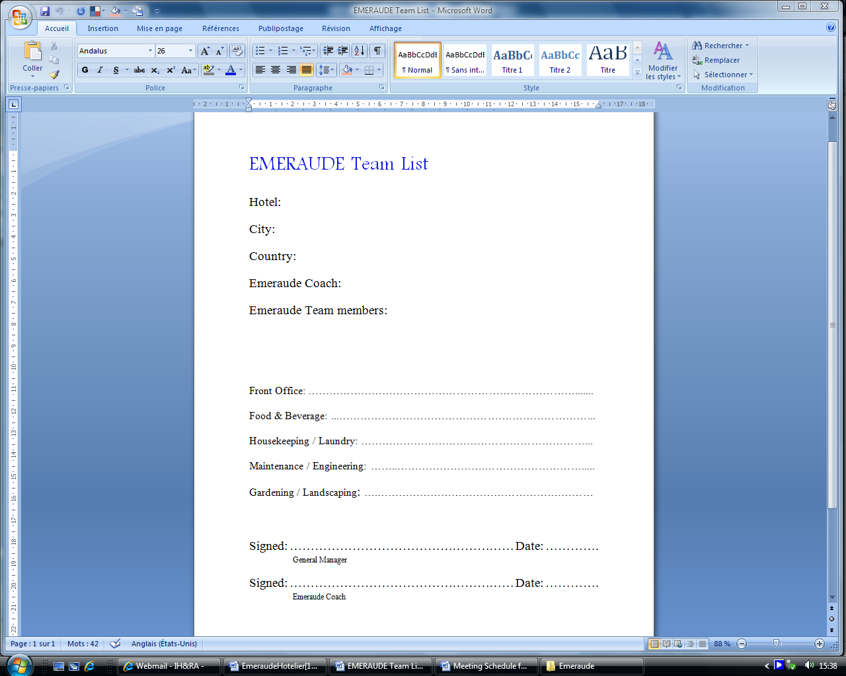Sample List for the Emeraude Team. Adapt the document to your hotel.

## 5.2 Sustainability Policy

The Sustainability Policy is based on the hotel’s selected criteria.

The Emeraude Team creates at least 10 declarations which function as guidelines for a sustainable development.

Try to develop your own strategy and to implement what you want to emphasize. The Sustainability Policy could be designed according to important or problematic issues in your region or country. It could also serve as an opportunity for the hotel to have a market advantage.

Do not forget to include all mandatory statements according to the criteria.

See a sample for the Sustainability Policy on the following page.

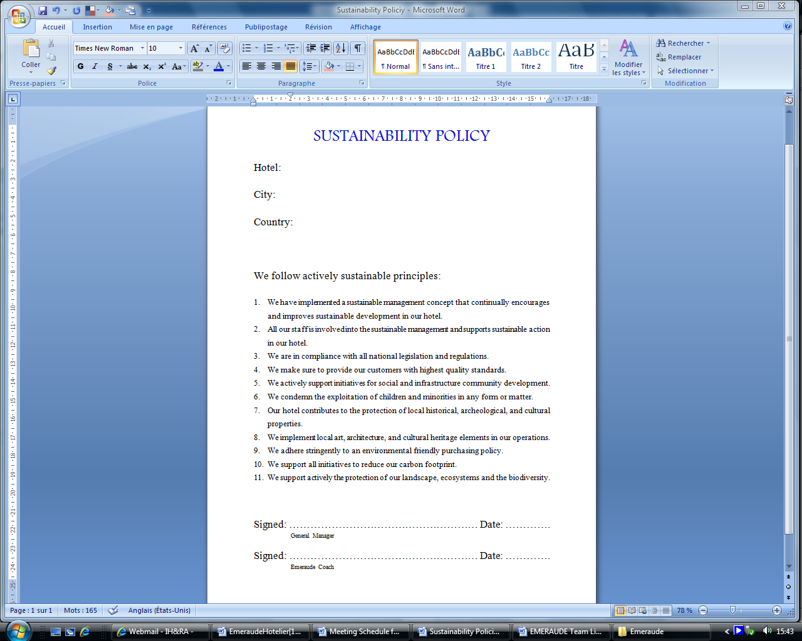

## 5.3 Action Plan

Once you have completed the checklist you are ready to take all necessary actions.

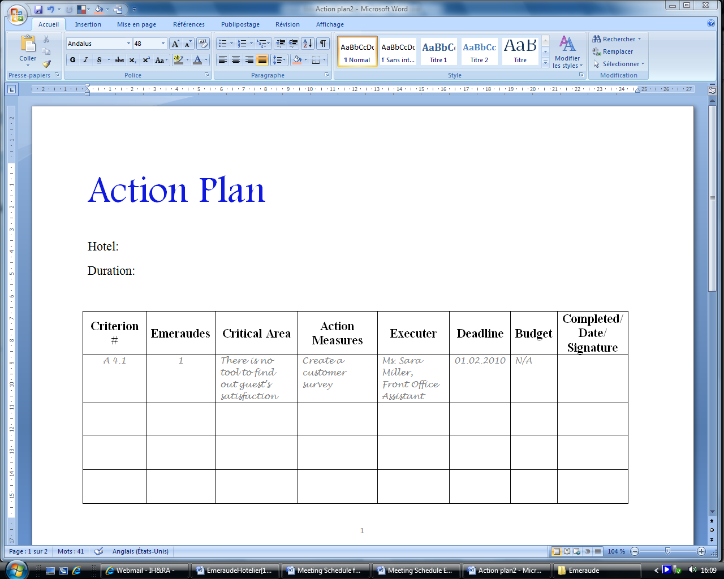Each action has to be documented in the Action Plan, which has a duration of two years, until the next certification. See a sample for the Action Plan below.

## 5.4 Emeraude Team Meeting Plan

Be sure that the Emeraude Team meets at least monthly.

See a sample for the Meeting Plan below.

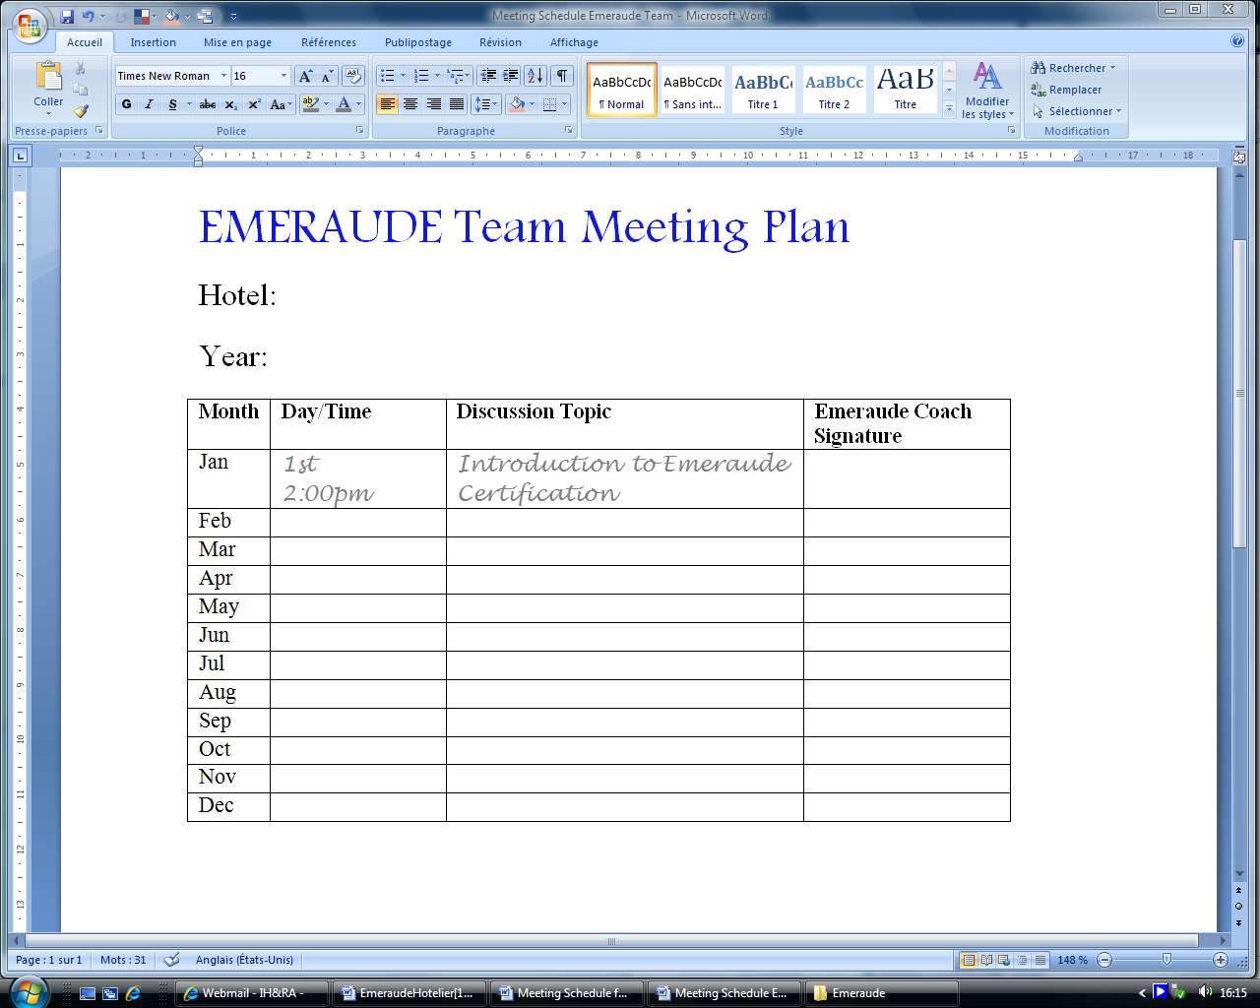

## 5.5 Staff Training Plan

Staff training meetings are organized by the Emeraude Team in order to train staff with respect to all sustainable relevant issues and the implementation of the measures.

In large hotels, only staff members in leading positions take part in the meetings.

In general, the Emeraude Team chooses how to implement the meetings.

* Meetings should take place at least quarterly
* If only staff members in leading positions participate in the meetings, a good communication strategy must be developed to inform all staff members of the meeting notes.

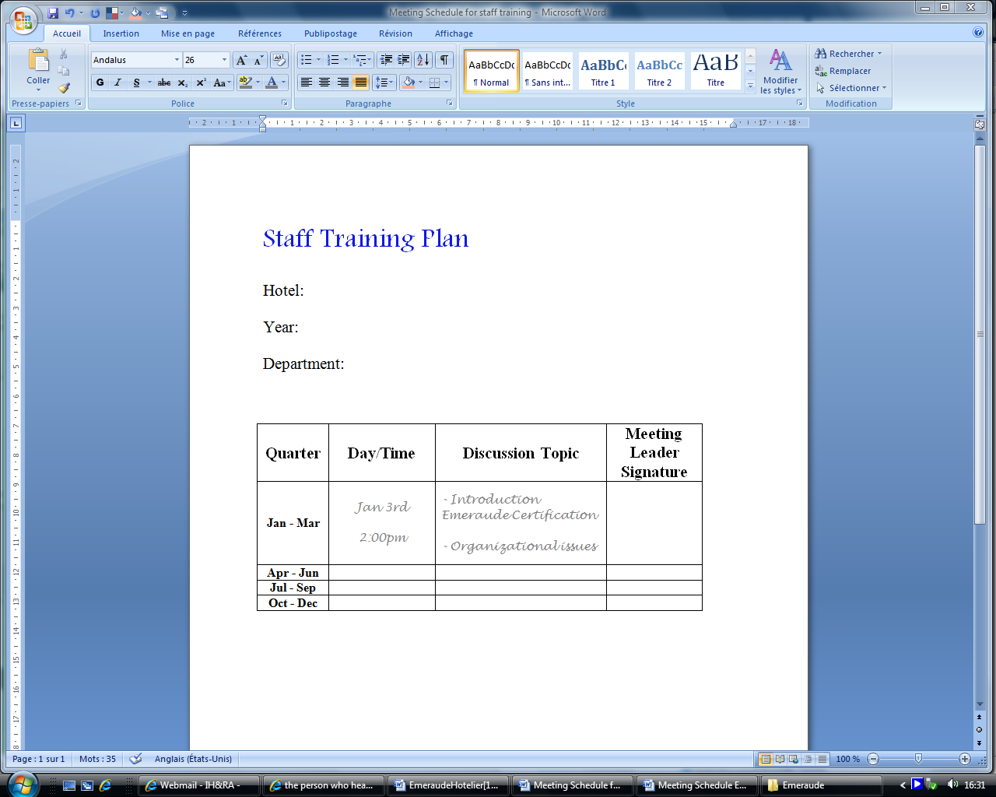See a sample for the Staff Training Plan below.

## 5.6 Consumption Spreadsheet

This spreadsheet measures the monthly and annual consumption of electricity, fuel, gas, water and carbon footprint.

See a sample Spreadsheet below.

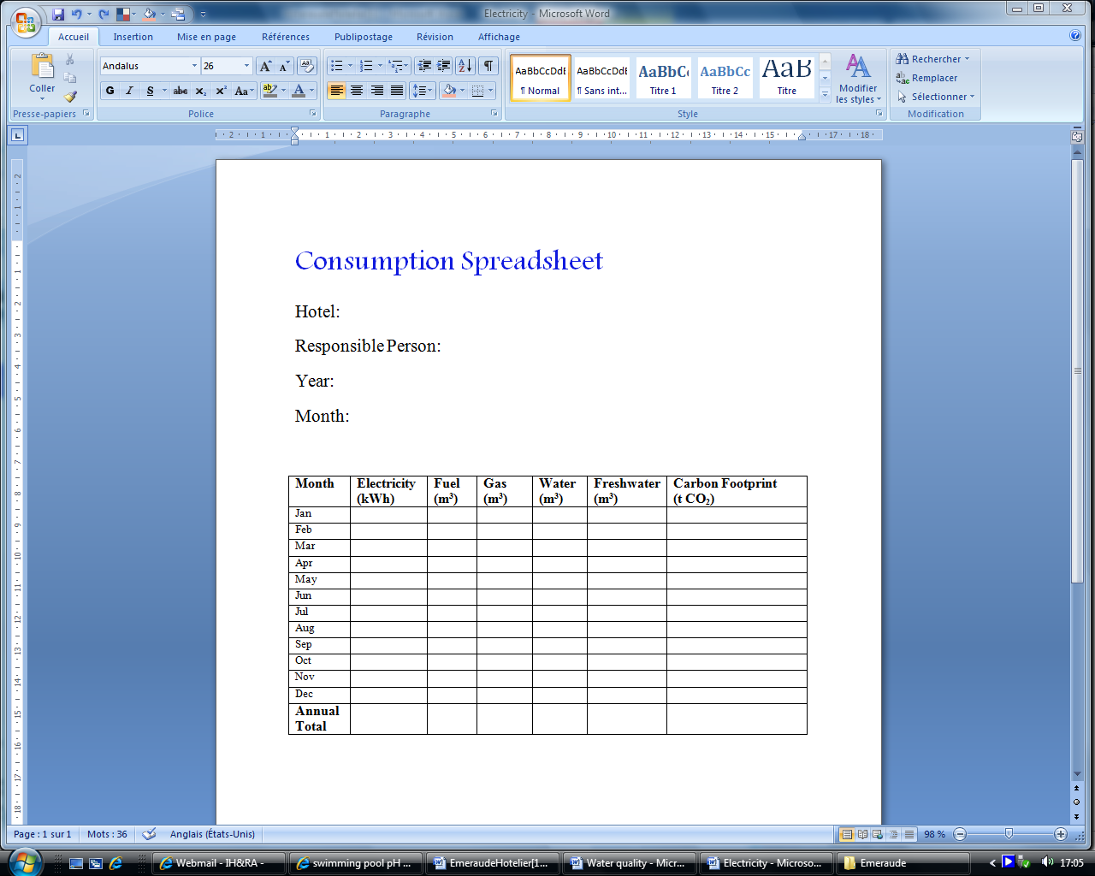

## 5.7 Inspection Spreadsheet

This spreadsheet documents inspections for the heating system and boiler.

See a sample Spreadsheet below.

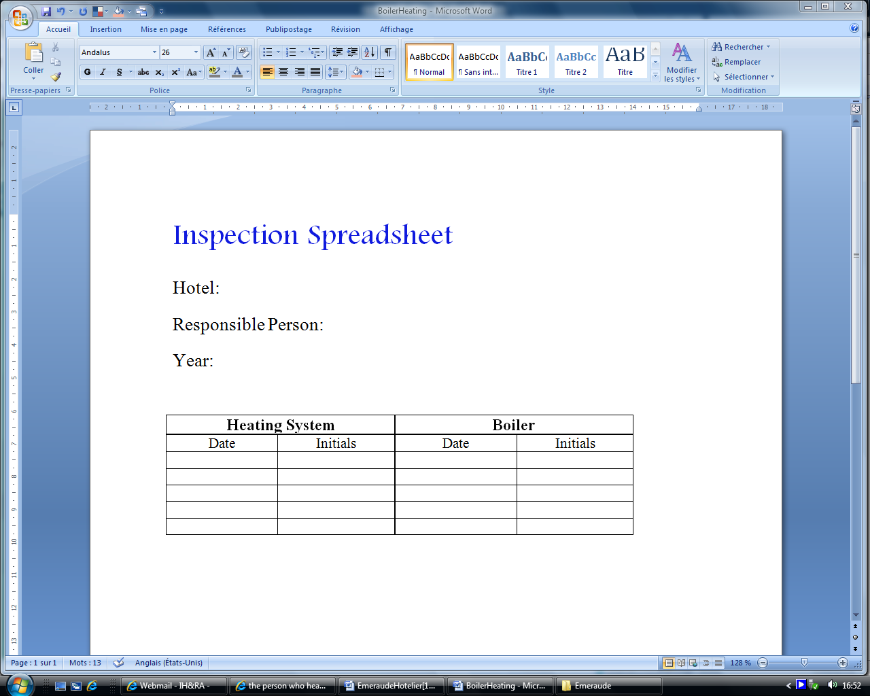

## 5.8 Water Quality

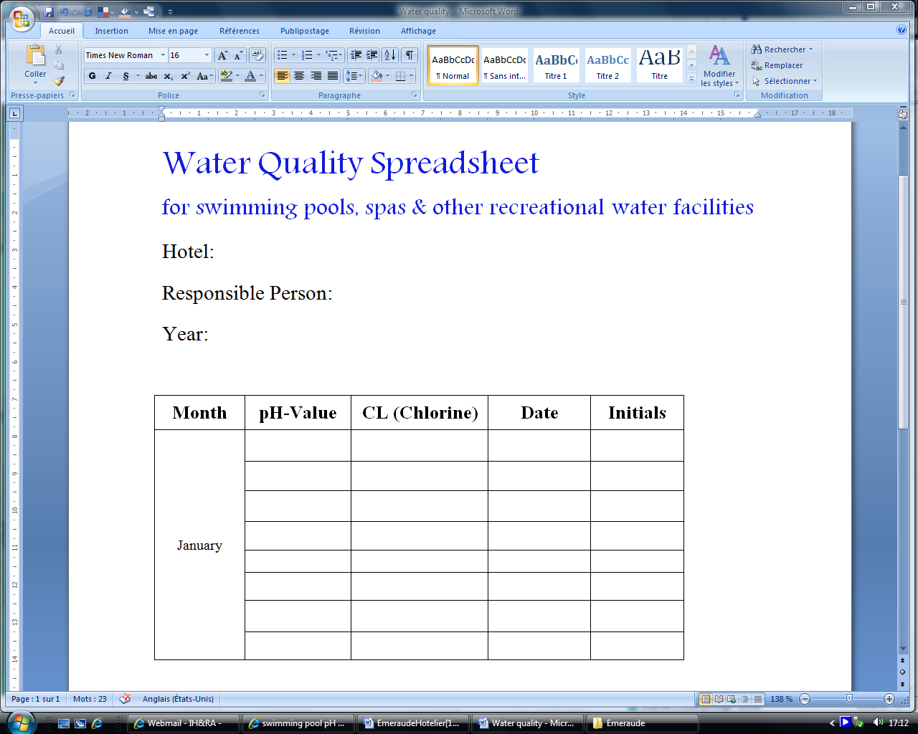This spreadsheet documents water quality inspections for swimming pools, spas and other recreational water facilities. These tests should be done extremely frequently, particularly if there is a high traffic of swimmers.

See a sample Spreadsheet below.

# **Appendix**